(Approx. 558 words)

Using the Virtual Desktop (Task View)
By Rosita Herrick, Forum Leader, Sarasota Technology Users Group, Florida
February 2018 issue, STUGMonitor
www.thestug.org
rherrick (at) aol.com

I believe that the Task View option is an ignored productivity feature. Staying productive is often as much about staying organized as anything else, especially while multitasking. And when it comes to productivity on PCs, many people may opt for a desktop setup with multiple monitors. But that’s not an option for everyone – particularly if you do most of your work on the go with a laptop.

Thankfully, Windows 10 includes a handy feature that can mimic the experience of spreading your work around multiple monitors without the extra hardware: virtual desktops, or as the shortcut on the task bar displays, Task View. Virtual desktops essentially let you multiply the number of distinct desktops you have at your fingertips on one PC. This can come in handy if you just want to keep work tasks separated from your personal windows. But if separating tasks is your goal, the Task View lets you keep things separate and organized while still having access to everything at a click

How to Use Windows Virtual Desktops

Accessing your virtual desktops is fairly easy, but it’s not immediately obvious unless you’re looking for it. The most obvious way to get started is through the Task View icon located on your taskbar. You’ll find it located to the right of the Cortana search bar; it looks like a rectangle flanked by two other, partial rectangles. Click the Task View icon and you’ll be greeted with a screen that shows all your currently open apps. This is essentially a birds-eye view of your first, primary desktop, which can be quite an asset

On the bottom right-hand corner of the Task View screen, you’ll find a “+” icon that says “New Desktop” underneath.
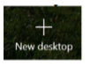
Simply click the button and Windows 10 will surface a bar at the bottom of your screen showing your original, primary desktop and the newly created one.

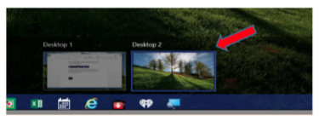
You can keep tapping or clicking the “New Desktop” button to add as many as you want (based on the capabilities of your PC).

Switching between desktops is as easy as selecting one from the Task view.

View screen. You can also drag and drop specific programs from Task View on one desktop to the others listed on the screen. And when you’re done with a desktop, you can close out of it by hovering over it with your mouse and clicking the “X” button within Task View. The benefit of using Task View is that if you close one screen by mistake, the active programs gets transferred to the preceding screen.

Getting around quickly with keyboard shortcuts
Of course, while the steps described above are fine for getting started, you’ll want to move around more quickly as you get used to things. Fortunately, there are some keyboard shortcuts associated with virtual desktops that can speed things up.
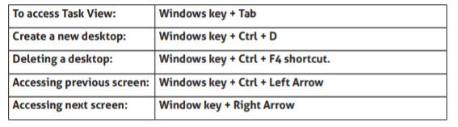

Getting used to the keyboard shortcuts can take some time. However, once you do, you’ll find yourself zipping through things at the speed of light.

Task View restricts the user to viewing one desktop at a time. However, the upshot is that it makes it that much easier to quickly switch between tasks without closing one task by mistake. And even if you have

